**DESIGNING VIRTUAL ZOOM BACKGROUND**

**PROJECT REPORT TEMPLATE**

1.INTRODUCTION

Overview

The Virtual Background feature allows you to display an image or video as your background during a meeting in a zoom room.

This feature requires a green screen to allow zoom to detect the difference between you and your background.

PURPOSE

To achieve the best virtual background effect, Zoom recommends using a high- constrast, Soild-colour backdrop,preferably a green screen.

Which can provide you with more privacy or a consistent and professional look for presentation.

2.PROBLEM DEFINITION & DESIGN THINKING

EMPATHY MAP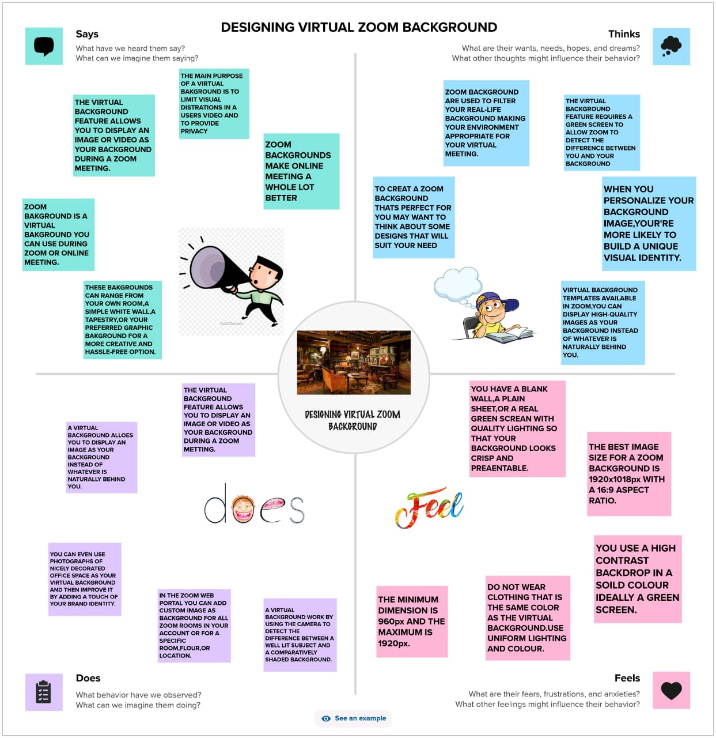

IDEATION & BRAINSTORMING MAP

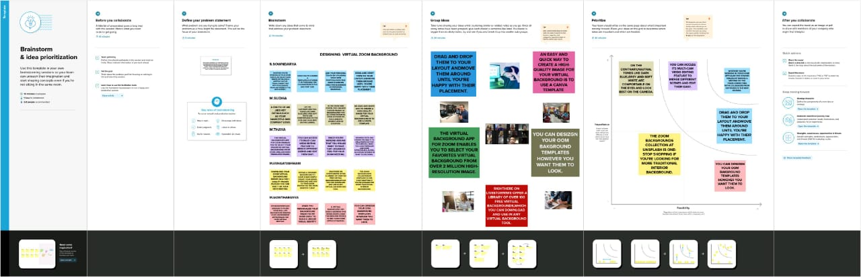

3.RESULT



4.ADVANTAGES AND DISADVANTAGES:

When using a virtual video background , there is the chance of a mishap. Things could go awry if you choose the wrong image, fing your video quality degraded,or have poor lighting.

Virtual bakgrounds work well when you have strong lighting that allows the computer to detect where you end and your background begins.

5.APPLICATION

The virtual background feature allows you to display an image or video as your background during a zoom meeting, which an provide you with more privacy or a consistent and professional look for a presentation.they may seem obvious but as cool as they look,virtual background are’t real and in a world where a majority of our interation happens from behind a computer screen, people crave realness and authenticity now more than ever before.

6.CONCLUSION:

A blurred background is a great way to make a professional impression during a video call. It shows you’re serious about the meeting and willing to invest in the right tehnology. Plus, it’s a great way to avoid awkwardness if your home is not as tidy as you’d like.